Atlanta Police Department
Public Affairs Unit
226 Peachtree Street, S.W.
5th Floor
Atlanta, Georgia 30303
NEWS
RELEASE
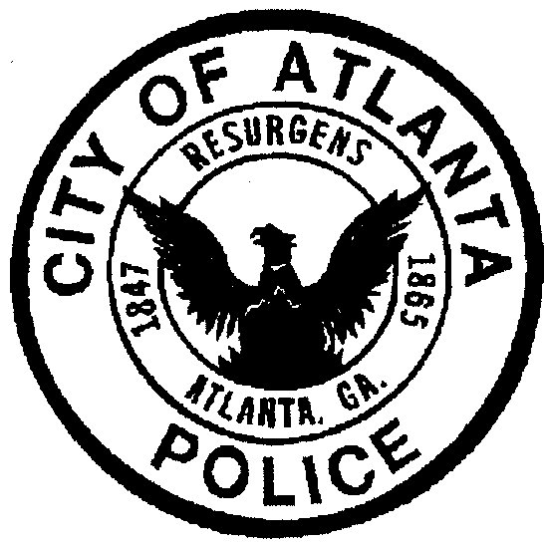

FOR IMMEDIATE RELEASE Contact: Carlos Campos

June 27, 2012 Public Affairs Unit

(404) 546-4212

ATLANTA POLICE DEPARTMENT RECEIVES LAW ENFORCMENT GRANT TO HIRE VETERANS

Funding will allow creation of Atlanta BeltLine Path Force

The Atlanta Police Department will receive an estimated $1.8 million in federal Community Oriented Policing Services (COPS) grant money over the next three years, allowing the Department to hire 15 military veterans as officers. The new positions will allow the APD to reallocate existing personnel to create the “APD Path Force,” dedicated to providing security and patrols to the developing Atlanta BeltLine.

The U.S. Department of Justice Office of Community Oriented Policing Services (COPS) announced its funding awards this week. The grant stipulated that the city match $966,075 over the three-year grant period.

The grant requires the Atlanta Police Department to hire military veterans who have served on active duty at any time period of more than 180 consecutive days, any part of which occurred during the period on or after September 11, 2001, and who has been discharged or released from active duty in the armed forces under honorable conditions.

In addition, as proposed in the COPS Hiring Program grant application, the Atlanta Police Department will partner with the Atlanta BeltLine project to implement the APD Path Force. The Atlanta BeltLine is a comprehensive revitalization and mobility project that will provide a network of public parks, multi-use trails and transit by re-using 22-miles of historic railroad corridors circling downtown and connecting 45 neighborhoods directly to each other. It will include 22 miles of pedestrian-friendly rail transit, 33 miles of multi-use trails and more than 1,200 acres of new parkland.
The APD Path Force will be comprised of 15 officers tasked with law enforcement within the Atlanta BeltLine footprint. These 15 officers will work in partnership with public, private and other City of Atlanta departments to develop long term initiatives that will alleviate crime, increase the quality of life and develop security and safety ideas that will promote participation and patronage of the Atlanta BeltLine. Awarding of the grant will allow the department to move forward with hiring the veterans; there is no date set yet for deployment of the Path Force.

-more-
“This grant award will provide 15 officer positions and will assist us to provide police services to the city at large, while providing employment opportunities to those who have selflessly served our country,” said Atlanta Police Chief George N. Turner. “I am pleased that we were able to secure this grant; it is a boost in helping us to reach our goal of becoming the safest big city in America.”

A full-service police agency, the Department has adopted a community-oriented policing philosophy and relies heavily upon community input and collaborative problem-solving strategies. It is through heightened community involvement in public safety matters that the Atlanta Police Department will most effectively address its many priorities, including, but not limited to youth-related crime, domestic violence and the fight against crime in Atlanta.

With an authorized strength of more than 2,000 sworn officers, the Atlanta Police Department is the largest law enforcement agency in the State of Georgia, and a dedicated, high-profile force for positive change in our communities.
###

The mission of the Atlanta Police Department is to reduce crime and promote
the quality of life, in partnership with our community.

www.atlantapd.org
twitter @Atlanta_Police

