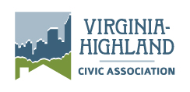
P.O. Box 8401, Station F
Atlanta, GA 31106

www.vahi.org

2015 Grant & Community Gift Application

Deadlines and Timing
Grant applications must be submitted to budget@VAHI.org by August 15, 2015. Awardees will be determined by the Annual General Meeting in September. Grants will be distributed in November.

Grant amount requested $Click here to enter text.

Applicant Information
Organization Click here to enter text.
Representative name Click here to enter text.
Address Click here to enter text.
Phone Click here to enter text.
Email Click here to enter text.

Grant Purpose
Description of what the grant would be used for, any anticipated matching funds, the cost of the project, and the anticipated benefit to Virginia-Highland.
Click here to enter text.

Acknowledgement
I agree that if the requested grant is awarded, our organization will provide a report on the use of the funding and specific results (with photos where applicable) by May 1st to communications@vahi.org. Additionally, the VHCA grant will be recognized by the following newsletter, donor list, website, etc.:
Click here to enter text.

